CS 255 System Design Document Template

This template lays out all the different sections that you need to complete for Project Two. Each section has guidance to prompt your thinking. You will need to continually reference the interview transcript as you work to make sure that you are addressing your client’s needs. There is no required length for the final document. Instead the goal is to complete each section based on what your client’s needs are. Remove this note when you are finished, and replace all bracketed text with the relevant information.

UML Diagrams

UML Use Case Diagram
[In Module Six, you were asked to complete a use case diagram based on your system design. If you would like to make any adjustments to your diagram, please do so. Please insert your use case diagram here. Check to make sure that you included appropriate components and symbols and that your design meets the client’s needs.]

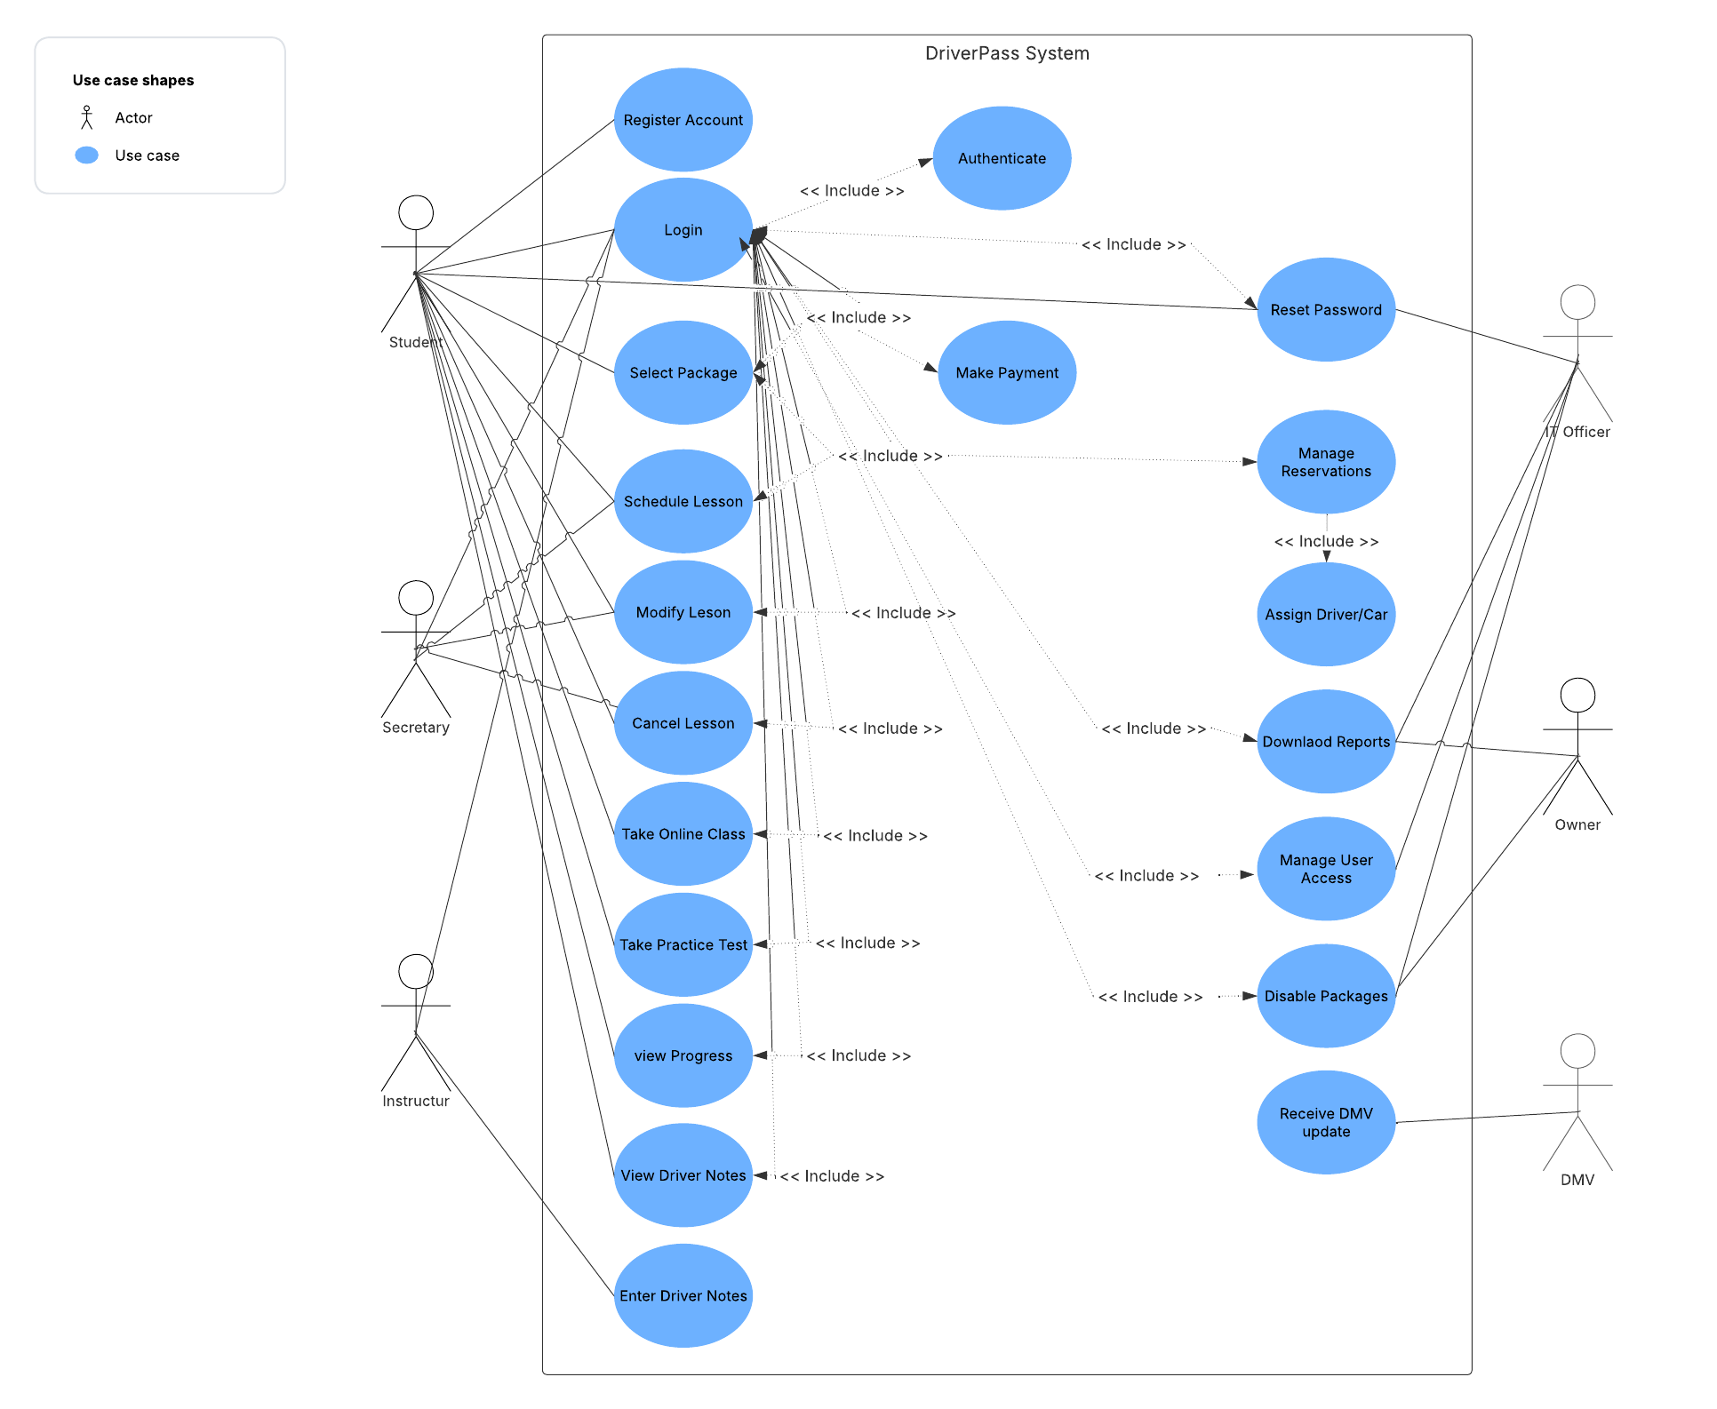

UML Activity Diagrams
[You were asked to choose two use cases and create two activity diagrams, one for each use case. Please insert both of your activity diagrams here. Check to make sure that you included appropriate components and symbols and that your design meets the client’s needs.]

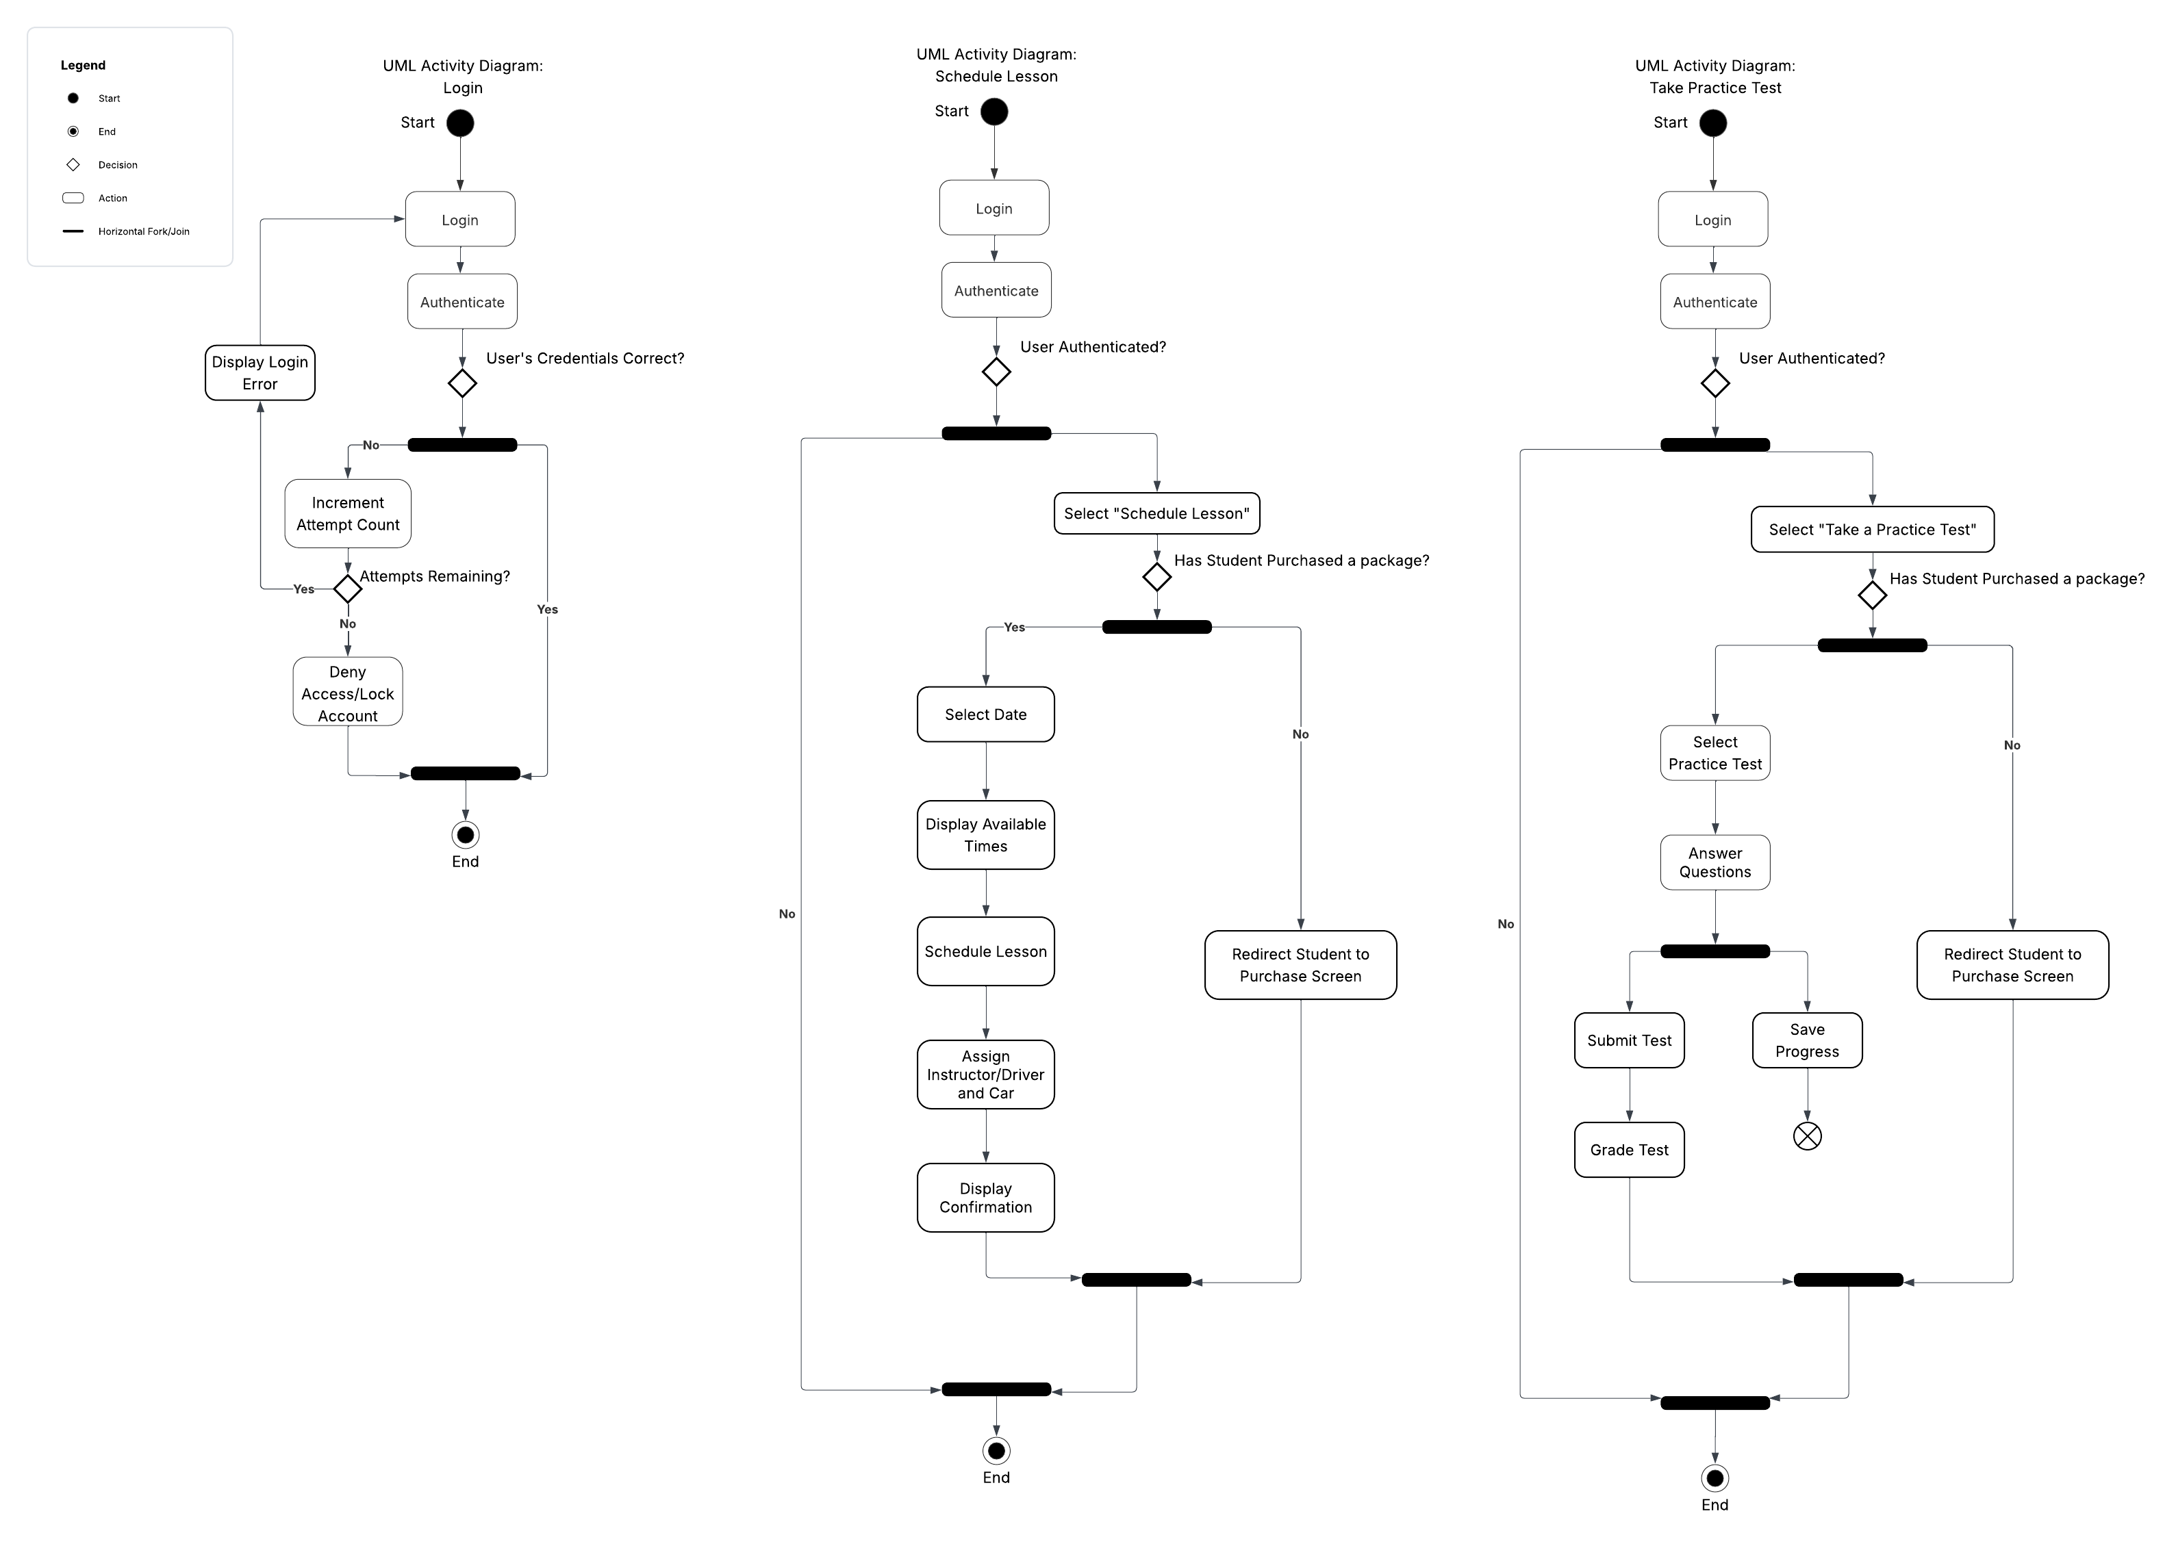

UML Sequence Diagram
[You were asked to create a sequence diagram based on one of the use cases you chose. Please insert your sequence diagram here. Check to make sure that you included appropriate components and symbols and that your design meets the client’s needs.]

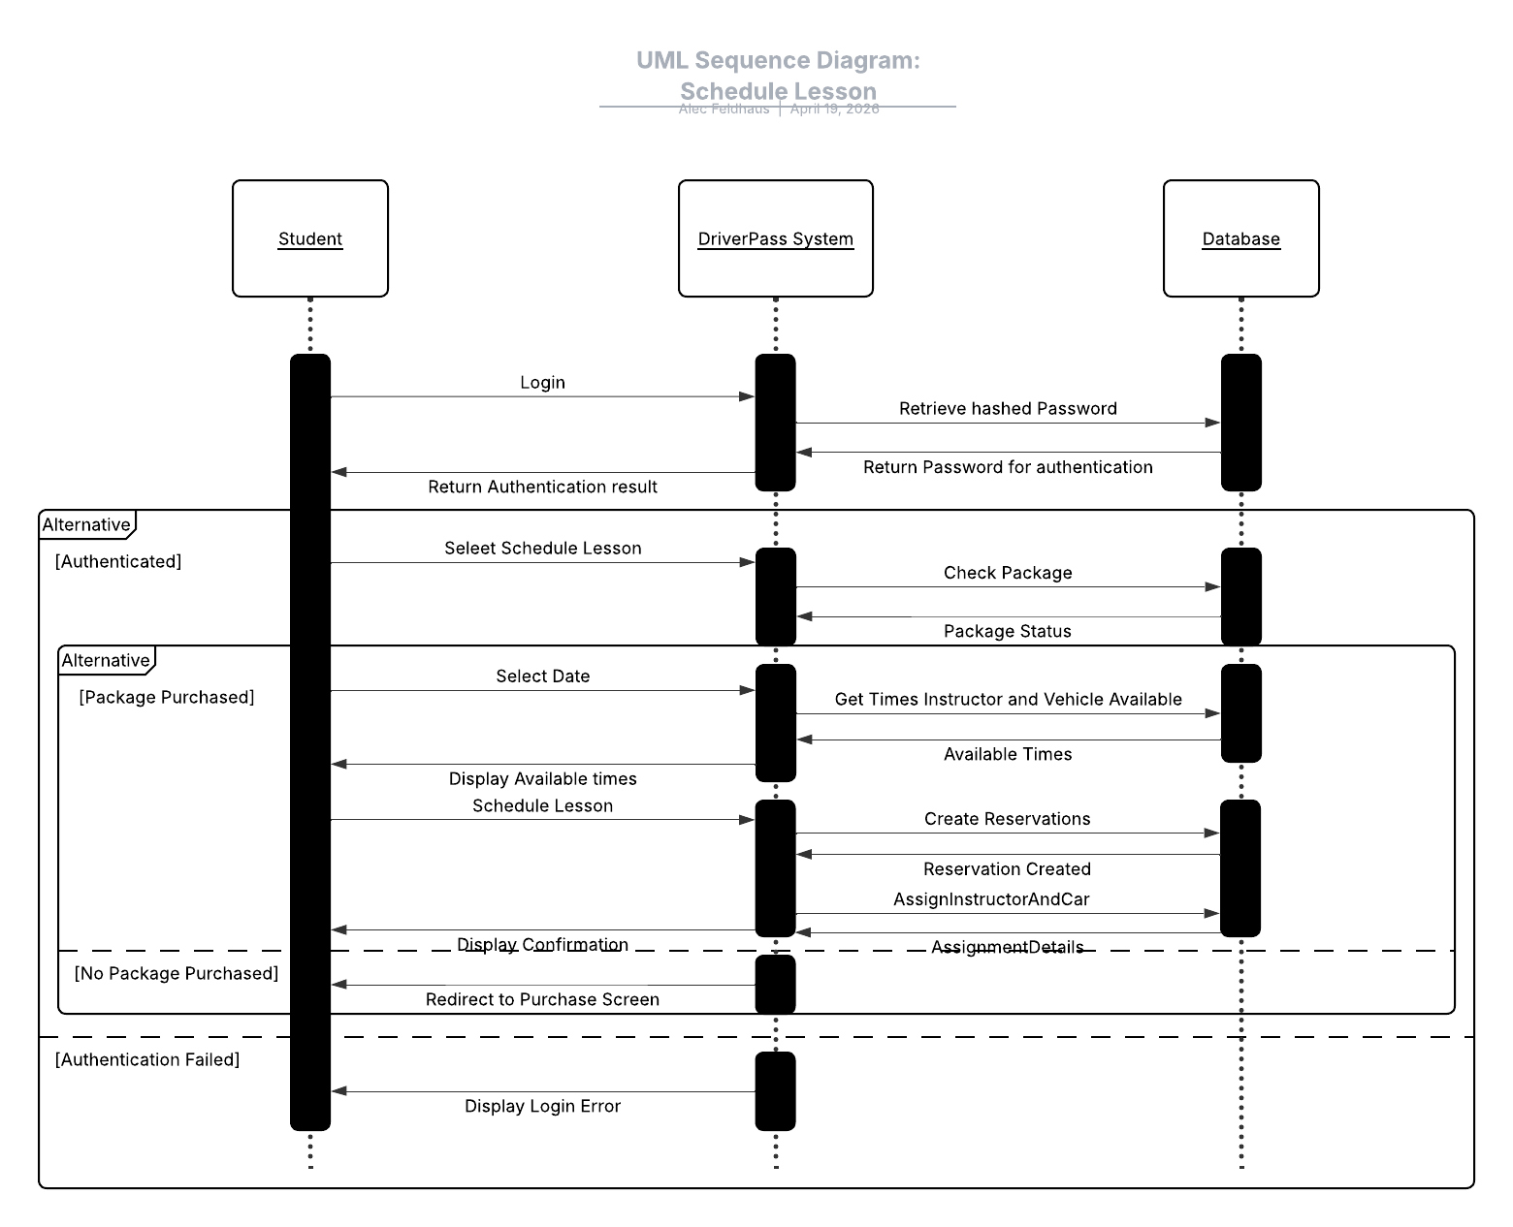

UML Class Diagram
[You were asked to create a class diagram based on the different classes and attributes needed for your system design. You are not required to include methods, but you may if you wish. Please insert your class diagram here. Check to make sure that you included appropriate components and symbols and that your design meets the client’s requirements.]

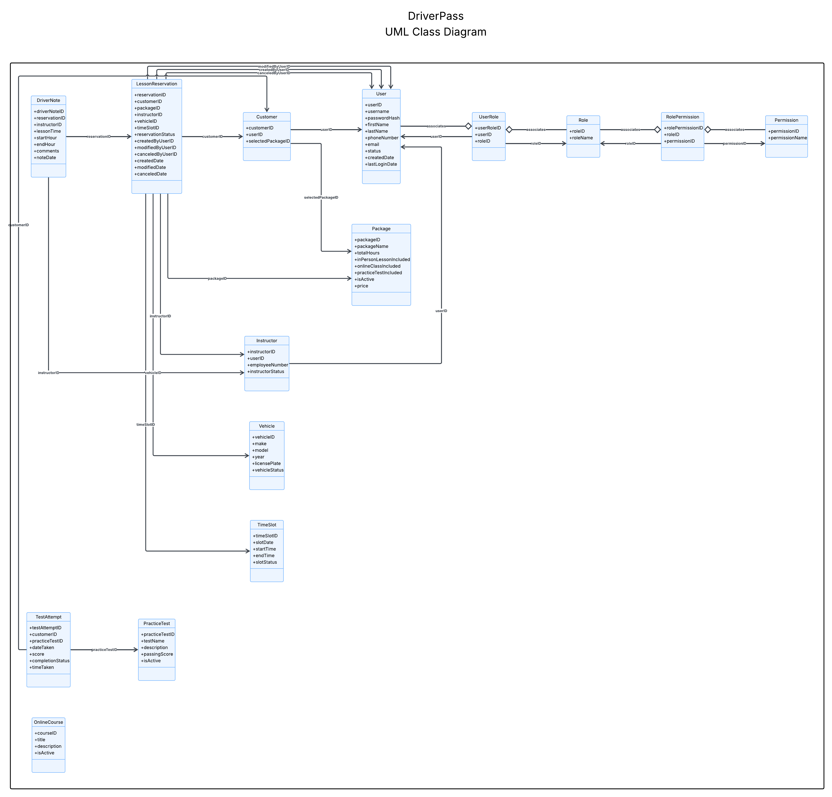

Technical Requirements
[Based on the diagrams you have created, describe the technical requirements of your system. These requirements should address the required hardware, software, tools, and infrastructure necessary for your system design.]

Technical Requirements

The technical requirements of the proposed DriverPass system are provided to describe the hardware, software, tools, and infrastructure needed. These technical requirements are based on the business requirements, nonfunctional requirements, and the UML diagrams created for the DriverPass system. Since DriverPass wants a secure web-based platform that combines online learning, practice tests, on-the-road training scheduling, reporting, and administrative functionality and auditing, the system must be supported by technology that is cloud-hosted, scalable, secure, and accessible from different devices.

Hardware Requirements
- Web-based cloud-hosted system.
  - This allows DriverPass to access the system from any computer or mobile device with internet access.
  - This also allows the company to focus on running the business instead of dealing directly with backup and infrastructure concerns.
  - Since the client wants the system to run off the web, preferably over the cloud, the hardware environment should be hosted.

- Standard desktop computers, laptops, tablets, and smartphones for users.
  - This allows students, secretaries, instructors, the owner, and the IT officer to access the system from different devices depending on their needs.
  - This supports the client’s request for flexible online access from both computers and mobile devices.

- Scalable server resources for processing and storage.
  - This allows the system to support students scheduling lessons, taking practice tests, and viewing progress while staff members manage reservations, accounts, and reports at the same time.
  - This is important because the platform must support both business operations and customer usage simultaneously.
  - The hardware environment should also support storage for customer records, reports, lesson notes, and activity logs,.

Software Requirements
- Browser-based application.
  - This allows the system to be accessed through a standard web browser.
  - This supports the client’s request for access from computers and mobile devices.
  - The user interface should be web-based so that students and employees can access the system from desktop and mobile browsers.

- Server-side application for business logic.
  - This allows the system to process login, authentication, package checks, lesson scheduling, instructor and vehicle assignment, practice tests, reporting, and driver notes.
  - The backend should support the main functions shown in the use case, activity, sequence, and class diagrams.

- Role-based access control software.
  - This allows the system to provide different privileges to the owner, IT officer, secretary, instructor, and customer.
  - This helps prevent users from accessing functionality outside their needs.
  - This results in more accurate access control and makes sure each user only sees the functionality needed for their role.

- Authentication and account security support.
  - This allows the system to support login-based user access, password reset, account blocking capability, and temporary lockout after repeated failed login attempts.
  - This is necessary because the platform stores personal, scheduling, and payment information.
  - The software should also support authentication on each request (best practices) and secure account management for the IT officer.

- Support for online classes, practice tests, progress tracking, driver notes, and downloadable reports.
  - This allows DriverPass to support both the learning management software side and the scheduling side of the business.
  - This is necessary because the system must help students prepare for the DMV exam while also supporting reporting and administrative functions.

Database Requirements
- Database-backed system.
  - This allows the system to store customer information, reservations, package selections, driver assignments, vehicle assignments, lesson notes, reports, practice tests, and progress records.
  - This is necessary because the system must support scheduling, account management, and record tracking.

- Relational database with normalization.
  - This allows the system to store connected information across users, students, roles, permissions, reservations, instructors, vehicles, and time slots without unnecessary duplication.
  - A relational database with normalization allows us to connect appointments with the various users and the vehicle by their corresponding IDs for accurate real-time updates of reservations.
  - Accuracy is achieved through normalization and tying the registration to the customer and other tables via their IDs. Thus,if this data is changed it is still connected to only that customer or user.

- Role-based access data structures.
  - This allows the system to separate functionality between the owner, the IT officer, the secretary, the instructor, and the customer.
  - This supports the class diagram structure of users, roles, permissions, and related data needed to support different access levels in the system.

- Reservation and time-slot support for two-hour lessons.
  - This allows the system to correctly manage appointments across multiple drivers and cars.
  - This is important because lesson reservations must be clearly tied to the correct customer, driver, time, and vehicle.
  - The database must support fixed two-hour lesson scheduling by linking each reservation to a specific date, time slot, instructor, and car.

- Activity tracking and audit support.
  - This allows DriverPass to know who made a reservation, who canceled it, and who modified it last.
  - This helps identify who is responsible if something goes wrong.
  - This supports auditing and report generation if problems occur.

- Secure storage of customer and payment data.
  - This allows the system to maintain correct personal and payment information for each customer.
  - This supports both registration and appointment scheduling functions.
  - The system should securely store customer personal information, account data, and payment-related records because these are necessary for registration, scheduling, and payment processing.

Infrastructure Requirements
- AWS cloud hosting using Linux.
  - Using technologies like Spring Boot Web MVC or Spring Boot REST for the backend, the system can utilize a web server and run on a Linux distribution in a cloud-hosted environment.
  - Provides a hosted environment that reduces the need for DriverPass to spend time maintaining the system (ie backups).

- Web server, backend application, and database hosting.
  - This allows the web interface, system business logic, and stored data to work together as one complete platform.
  - This is necessary because, as the sequence diagram shows, interaction between the student, the DriverPass system, and the database are all required during scheduling, authentication and every other function.

- Secure network communication.
  - This allows data to be protected between the client browser and the server.
  - This is important because login data, customer information, payment information, and reservation information should not be exposed during transmission.

- Storage for reports, logs, and downloadable information.
  - This supports the owner’s request to access data online and also download certain reports for work offline.
  - The infrastructure should support file storage for reports, logs, etc.

- DMV update integration support.
  - This allows the system to reflect updated DMV rules, policies, and sample questions over time.
  - This helps the platform remain current without requiring a full rebuild.
  - The infrastructure must support receiving DMV updates so DriverPass can receive notifications when changes occur.

Security Requirements
- Login-based user access.
  - This allows the system to protect customer and employee information by requiring credentials before account access is granted.
  - This is necessary because the platform stores personal, scheduling, and payment information.

- Role-Based Access security.
  - This allows the system to provide different privileges to the owner, IT officer, secretary, instructor, and customer.
  - This helps prevent users from accessing functionality outside their needs in the system
  - This supports the role-based interface and administrative access requirements identified earlier.

- Password reset functionality.
  - This allows users who forget their password to regain access without requiring manual intervention for every case.
  - This matches the DriverPass’ stated need for automatic password reset capability.

- Account blocking capability.
  - This allows the IT officer to block access when an employee is let go or when account access becomes a concern.

- Secure transmission and storage of personal and payment data.
  - This allows customer information and payment information to be protected during use and storage at rest.
  - This is important because the system collects sensitive registration and payment data.

- Audit trail of user activity.
  - This allows DriverPass to review who made changes within the system.
  - This supports both auditing and security.

- Temporary lockout after repeated failed login attempts.
  - This allows the system to respond to possible brute force hacking attempts by restricting repeated login failures.
  - This helps reduce the risk of unauthorized access.

User Interface and Access Requirements
- Web-based interface accessible from a computer or mobile device.
  - This matches DriverPass’ request for access from any computer or mobile device and a system that runs off the web, preferably over the cloud.

- Role-based interface for the owner, IT officer, secretary, instructor, and customer.
  - This allows each user to see the functions appropriate for their role.
  - The owner needs access to business data and reports, the IT officer needs account maintenance and access control functions, the secretary needs appointment and student information management, the instructor needs lesson note functionality, and the student/customer needs access to scheduling, classes, and practice tests.

- Customer-facing pages for scheduling, training, and progress tracking.
  - This allows students to make, cancel, and modify appointments online through their account.
  - This also allows students to access online classes, complete practice tests, and review their progress in the system.

- Progress display for online tests.
  - This allows the user to view the tests they have taken, what is in progress, and what has been completed.
  - The interface should display items such as test name, time taken, score, and status.

- Driver notes section for lesson tracking.
  - This allows the user to view lesson information and comments left by the Instructor.
  - This should show lesson time, start hour, end hour, and driver comments.

- Administrative panel support.
  - This allows the owner and IT officer to manage reports, package settings, account access, and other system oversight functions.
  - This also allows the secretary to manage reservations and customer information on the admin side of the system.

Tools and Development Requirements
- Lucidchart or similar tool for system modeling.
  - This allows the UML diagrams to be created and maintained in a consistent format.
  - This supports the use case, activity, sequence, and class diagrams created for the system design document.

- Development tools for web application and database implementation and management.
  - This allows the system to be built, tested, and maintained as a browser-based application with a relational database backend.
- Logging and monitoring tools.
  - This allows the system to detect issues involving authentication failures, account problems, scheduling conflicts, or other administrative concerns.
  - This supports the requirement to inform administrators of important system and account issues.

- Expandable system design for future features.
  - This allows the system to support future improvements if DriverPass wants to expand the platform later.
  - This is useful even though the client stated that the present focus should remain on the current feature set.
  - By designing the system with a flexible database, administrative tools, and adaptable content support, DriverPass can expand later without requiring a full redesign.

